**Moulik Tammana**

**Q1. Try Test-Connection and nslookup commands for the following websites,** [**www.google.com**](http://www.google.com) **,** [**www.facebook.com**](http://www.facebook.com)**,** [**www.amazon.com**](http://www.amazon.com)**,** [**www.github.com**](http://www.github.com)**, and** [**www.cisco.com**](http://www.cisco.com)**.**

**The Test-Connection cmdlet in PowerShell is used to check network connectivity between your computer and a remote device (such as a website, server, or another computer). It works similarly to the ping command but provides more flexibility and options. We can also test multiple destinations at once rather than typing the command over and over again every time you want to ping a destination when you use the ping command.**

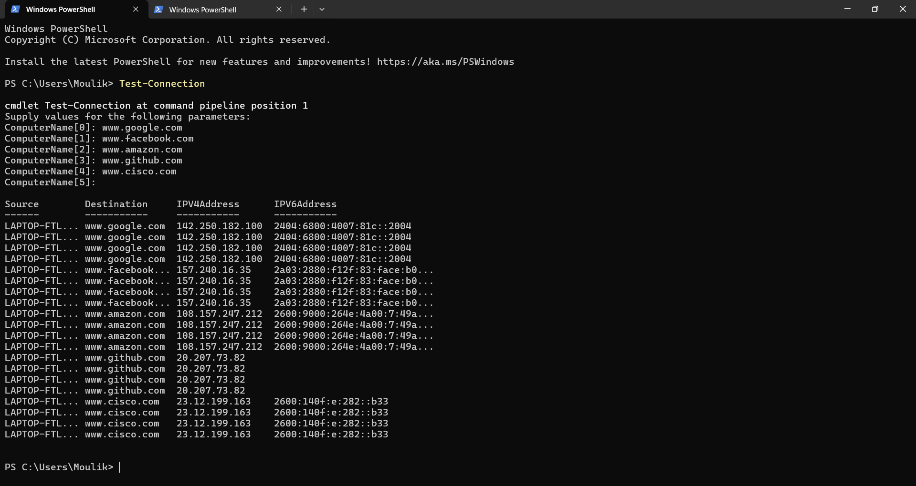

The nslookup command in PowerShell (and Command Prompt) is used for querying the Domain Name System (DNS) to obtain domain name or IP address mapping, as well as other DNS records. It is useful for network diagnostics and troubleshooting.

